# Durable Furnitures

Baker

## Monterey 6 Drawer Dresser

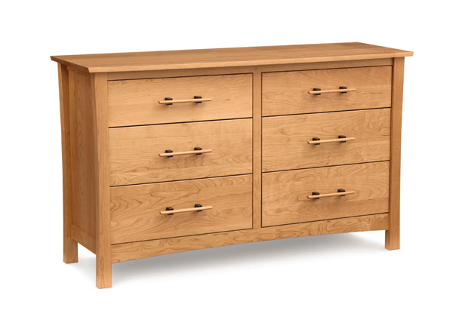

Copeland's luxury, cherry wood, Monterey 6 Drawer Dresser fuses American Art's & Crafts style with modern Japanese and Asian design. Handmade with natural cherry wood, this high end dresser can be customized online with your choice of 5 shades of cherry. Use the drop-down menu to see the choices for either natural cherry (no stain) or windsor cherry, autumn cherry, cognac cherry, saddle cherry or smoke cherry. Optional jewlery - accessory case is available. Our luxury Monterey Furniture Collection is handmade in Vermont using eco-friendly, sustainably harvested cherry wood.